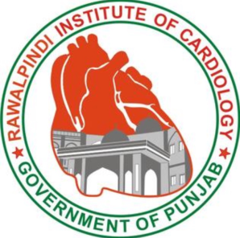
IVUS IMAGE INTERPRETATION WORKSHOP
VENUE: Rawalpindi Institute of Cardiology (RIC)
Registration Fee: Rs 20,000/-
Course Director: Dr. Asim Javed T.Bt
MBBS, FCPS, MRCP (UK), MRCPS (Glasg)
Fellowship in Interventional Cardiology (UK)
Assistant professor and Consultant interventional cardiologist
Registration Form
Name:
Father’s name:
PMDC Registration number:
Designation:
Hospital and City:
Contact number:
Email:
(Kindly send this form by email to doctorasimjaved@gmail.com Further confirmation and details for registration fee will be sent as reply to this registration form submission)

