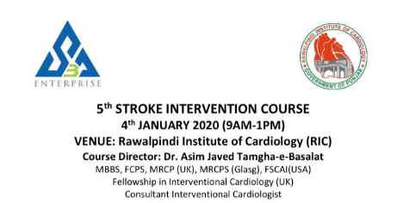
Registration Form
Name:
Father’s name:
PMDC Registration number:
Specialty:
Designation:
Hospital and City:
Mobile number:
Email:
