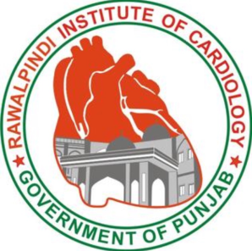
BEAUTY OF BASICS—ANTOMY AND SEQUENCES OF WHOLE BODY MRI
DATE: 22ND FEBURARY,2020
VENUE: Rawalpindi Institute of Cardiology (RIC)
Registration Form
Name:
Father’s name:
PMDC Registration number:
Designation/Level of training:
Hospital and City:
Contact number:
Email:
(Kindly send this form by email to dr_ummarahkamran@ric.gop.pk)

